Activity 2.3: Adding binary numbers
Adding denary numbers
Adding binary numbers is similar to adding denary numbers. Here is a reminder how we add denary numbers.
287 + 165
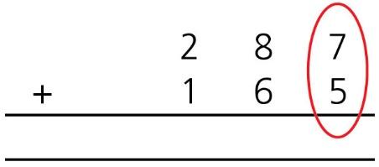
7 + 5 = 12, so we write down 2 and carry 1 to be added to the next column.

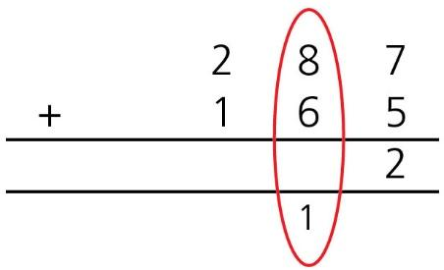
8 + 6 + 1 = 15, so we write down 5 and carry 1 to be added to the next column.

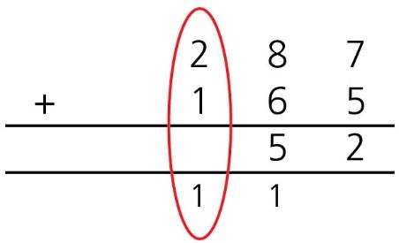
2 + 1 + 1 = 4, so we write down 4.

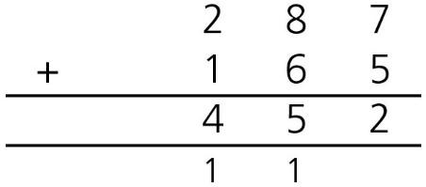

Adding binary numbers
In binary when the columns add up to more than 1, we also carry a digit. To do this, you need to know that:
- 1 + 1 = 10 in binary (1 + 1 = 2 in denary and 2 is written as 10 in binary).
- 1 + 1 + 1 = 11 in binary (1 + 1 + 1 = 3 in denary and 3 is written as 11 in binary).
Here is how we add 110 + 111 in binary.

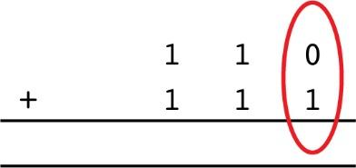
0 + 1 = 1 in binary, so we write down 1.

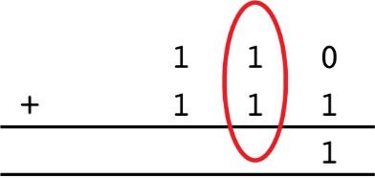
1 + 1 = 10 in binary, so we write down 0 and carry 1 to be added to the next column.

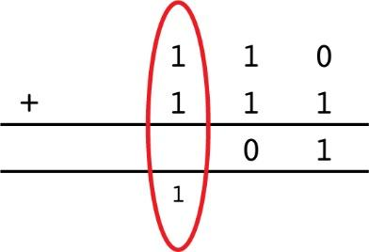
1 + 1 + 1 = 11 in binary, so we write down 1 and carry 1 to be added to the next column.

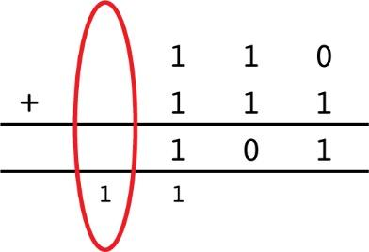
We just have 1 in this column, so we write down 1.

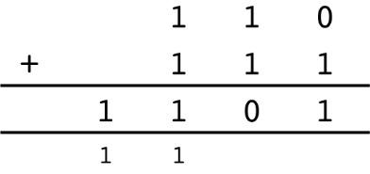

Complete the following binary additions, showing all your working.

 | 1 | 0
1 | 1 | 1

1 | 1 | 0 | 1
1 | 0 | 1 | 1

1 | 0 | 0 | 1 | 1
1 | 0 | 0 | 0 | 1

1 | 1 | 1 | 0 | 0
1 | 0 | 0 | 0 | 1

 | 1 | 0 | 0 | 1 | 1
1 | 1 | 0 | 0 | 0 | 1

1 | 0 | 0 | 1 | 0 | 1 | 1
1 | 1 | 1 | 1 | 0 | 1 | 1

